1. **INTRODUCTION**
   1. Overview

With the increase in consumer demand , the E-commerce space has boomed. This also leads to an increase in fierce competition in today's online marketplace. The ecommerce industry sells a diverse product line of grocery items and merchandise products, such as food, pharmaceuticals, apparel, games and toys, hobby items, furniture and appliances. The analysis of such industry is of great importance as it gives insights for the sales and profits of various products.

* 1. Purpose

E-commerce brings convenience for customers as they do not have to leave home and only need to browse website online,especially for buying the products which are not sold in near by shops.It could help customers buy wider range of products and save customers time.Consumers also gain power through online shopping.

**2. LITERATURE SURVEY**

2.1 Existing problem

1.Micro -target an online Audience

2.Personalize

3.Integrate Across Channels

4.Tap into logistics

5.Consider subscription commerce

6.Opt for Flexible Technology

7 .integrate Add REAL

8.Look For Social Commerce Opputunities

9.Support Cross-boarder and Global Sales

10.Create a Seamless Brand

2.2 Proposed solution

**Service Used:** IBM Cognos Analyticss

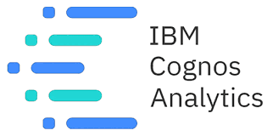

**3. THEORITICAL ANALYSIS**

3.1 Block diagram

IBM CLOUD

EXPORT THE DASHBOARD

DASHBOARD CREATION

1.REGION THAT ACCOUNTS FOR GREATER NO.OF ORDERS

2.FREQUENCY DISTRIBUTION OF QUANTITY ORDERED

3.PERCENTAGE SALES BY DIFFERENT PRODUCT CATEGORIES

4.PROFITABLE PRODUCTS OR THEIR SUB PRODUCTS IN LAST FEW YEARS

5.PRODUCTS THAT ICURRED LOSSES

6.PRODUCT THATG WAS ORDERED GREATER TIMES

7.YEARLY SALES FOR VARIOUS STATES

8.TREND IN PROFIT/SALES OVERF TIME (YEARS /MONTHS/QUARTERS)

DATA VISUALIZATION CHARTS

LOADING THE DATASET INTO IBM COGNOS DASHBOARD

LOGIN TO COGNOS

**3.2 HARDWARE/SOFTWARE DESIGNING**

SOFTWARE SPECIFICATIONS

|  |  |
| --- | --- |
| REQUIREMENT | SPECIFICATION |
| IBM ACCOUNT | You must have an account in IBM prior to begin. |
| IBM cognos analytics dashboard | 1.Contains Different Visualization  2.One Should Launch the cognos analytics dashboard. |
| Web browser | For all web browsers,the following must be enabled:   * Cookies * Java Script |

HARDWARE SPECIFICATIONS

|  |  |
| --- | --- |
| REQUIREMENTS | SPECIFICATIONS |
| Operating System | Microsoft Windows  Unix  Linux |
| processing | Minimum:4 CPU cores for one user.For each deployment,a sizing exercise is highly recommended. |
| RAM | Minimum 8GB |

**4 EXPERIMENTAL IVESTIGATIONS**

Analysis or the investigation made while working on the solution:

While working on the solution we investigated on what is E-commerce analysis, IBM cloud, IBM Watson studio, Ibm cognos service, Cloud Object Storage. The key role on investigation is collection of dataset.

IBM CLOUD ACCOUNT

IBM Acquired soft layer, a public cloud platform, to serve as the foundation for its IaaS offering. In October 2016, IBM rolled the soft layer brand under its Blue mix brand of PaaS offerings, giving users to access both IaaS and PaaS resources from a single console. IBM cloud provides a full-stack, public cloud platform with various products in the catalog, including options for compute, storage, networking, end to end developer solutions for app development, testing and deployment, security databases, and cloud native services.

Creating the IBM cloud account by going to the IBM cloud login page and click create on IBM cloud account. Enter our IBM id and an ID is created based on the email that we enter. Completing the remaining fields with our information and click create account by this the account is created.

DATASET COLLECTION:

The data collection on E-commerce analysis by:

* Articulate the problem early.
* Establish data collection
* Check our data quickly.
* Reduce the data
* Take the required data

**5 FLOWCHART**

IBM ACCOUNT

LOGIN TO COGNOS

EXPORT THE ANAYTICS

DASHBOARD CREATION

DATA VISUALIZATION

WORKING WITH DATASET

**6 RESULT**

This is the final Dashboard snippet of E-commerce

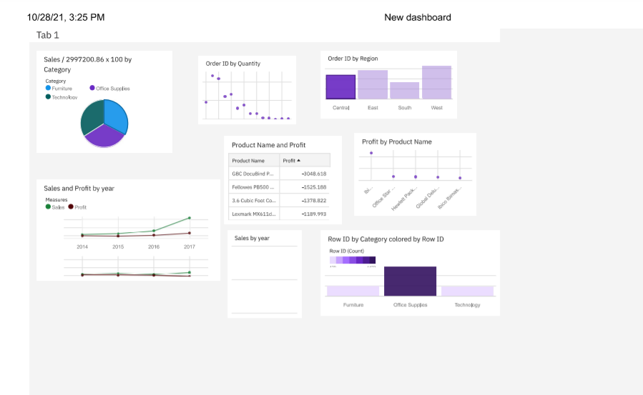

**7 ADVANTAGES AND DISADVANTAGES**

**ADVANTAGES**

* Lower Costs- reduces maintenance due to complete report coverage and a zero-footprint environment.
* Faster results- shortens reporting time due to seamless integration and adaptive authoring.
* Ability to use a varity of charts- Cross tabs, bar or 3Dbar,pie or doughnut, line ,guage funnel, scatter, dot density, waterfall, and so forth.
* High performance data access across all sources
* Improved decision making – reports and dashboards present data in easily- understood formats.

**DISADVANTAGES**

* Total Cost of Ownership (TCO) is more significant than other tools.
* Minimal forecast capabilities.
* Investment in Cognos R&D by IBM is declining.
* Won't work smoothly with large data sets having many parameters.
* Cross-browser compatibility is often problematic.

**8 APPLICATIONS**

The areas where this solutions can be applied:

* E-commerce analysis using IBM Cognos Dashboard
* The Visualizations can be done by using Visualizations Tools.

**9 CONCLUSION:**

From this entire we know fundamental concepts and work on IBM COGNOS**.**

* Gain a board understanding of visualization.
* Learn to build stunning modles on IBM cloud.
* To create data visualizations to understand**.**

**10 FUTURE SCOPE:**

Enhancements that can be made in the future:

* This model can be be further developed to suggest an any analysis can be done by using IBM Cognos Dashboard. And E-Commerce analysis were done by this Visualizations based on on the input parameters.
* We can scope the better job in future with the easy experience.

**11 BABILOGRAPHY**

Reference of previous works or websites visited/books referred for analysis about the project, previous solution findings.

**APPENDIX**

**………………………………………**